**Assignment 4 – MongoDB & PyMongo**

**# a)** Create collections “flights” inside database “airline_delayDB”

from  pymongo import MongoClient

import pandas as pd

import json

import numpy as np

import matplotlib.pyplot as plt

import seaborn as sns

def read_flight(csv_path):

    flight_data=pd.read_csv(csv_path)

    fl_data=json.loads(flight_data.to_json(orient='records'))

    collection.delete_many({})

    collection.insert_many(fl_data)

if __name__=="__main__":

    print("welcome to pymongo")

    client=MongoClient("mongodb://localhost:27017")

    print(client)

    db=client['airline_delayDB']

    collection=db['flights']

    read_flight('D:\python trianings\Assignment 4 on Pymongo_Flight_Delay\Flights_Delay.csv')

MongoClient(host=['localhost:27017'], document_class=dict, tz_aware=False, connect=True)

**# b)** Average arrival delay caused by airlines

average_delay=collection.aggregate([{'$group':{'_id':{},'avg_Delay':

                            {'$avg':'$ARRIVAL_DELAY'}}},{'$project':{'_id':0}}])

for item in average_delay:

    print(item)

{'avg_Delay': 7.545457931394093}

**#c)** Days of months with respect to average of arrival delays.

    #   [Create a suitable plot using matplotlib/seaborn]

avg_arvl_day=collection.aggregate([{'$group': {'_id':'$DAY','Avg_day_Delay':

                                    {'$avg':'$ARRIVAL_DELAY'}}},{'$sort':{'Avg_day_Delay':-1}}])

avg_arvl_day_df=pd.DataFrame(avg_arvl_day)

plt.style.use('seaborn-whitegrid')

plt.figure(figsize=(10,7))

sns.barplot(x=avg_arvl_day_df['_id'],y=avg_arvl_day_df['Avg_day_Delay'])

plt.xlabel('Day')

plt.show()

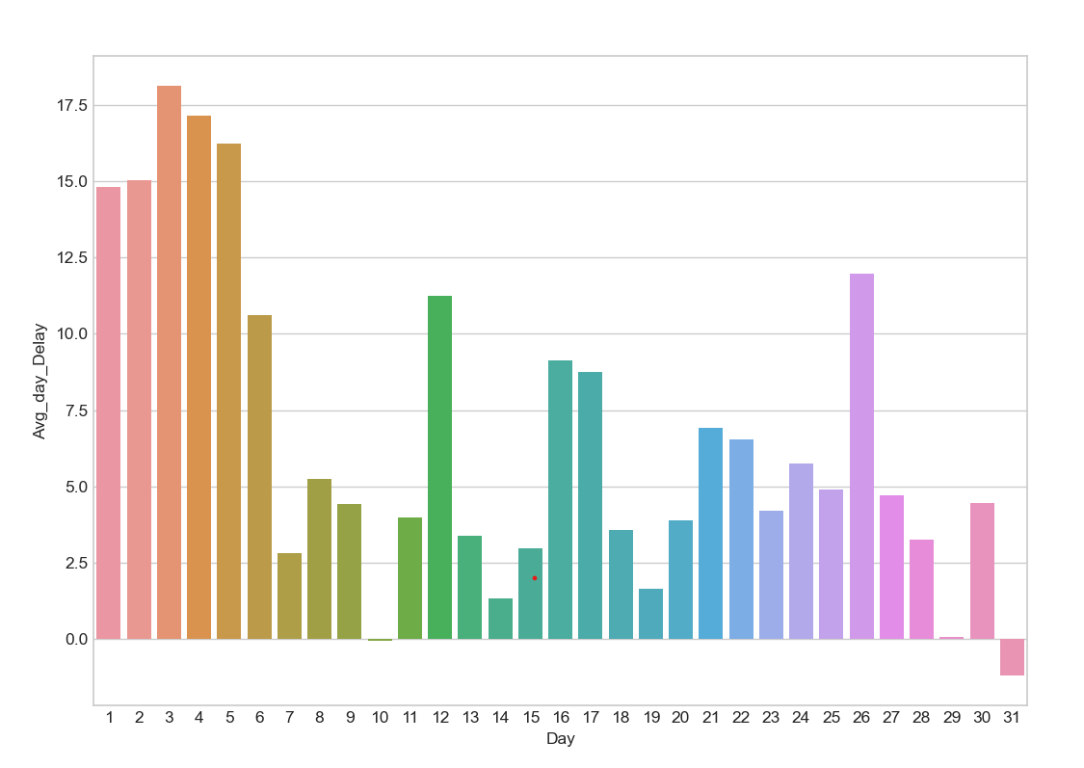

**#d**  Arrange weekdays with respect to the average arrival days caused.

    #  [Create a suitable plot using matplotlib/seaborn]

avg_arrival_wkday=collection.aggregate([{'$group': {'_id':'$DAY_OF_WEEK', 'Avg_Arrival_Delay':

                                          {'$avg': '$ARRIVAL_DELAY'}}},{'$sort': {'Avg_Arrival_Delay': -1}}])

avg_arrival_wkday_df=pd.DataFrame(avg_arrival_wkday)

plt.style.use('seaborn-whitegrid')

plt.figure(figsize = (10,7))

sns.barplot(x=avg_arrival_wkday_df['_id'],y=avg_arrival_wkday_df['Avg_Arrival_Delay'])

plt.title('average arrival days')

plt.xlabel('weekdays')

plt.show()

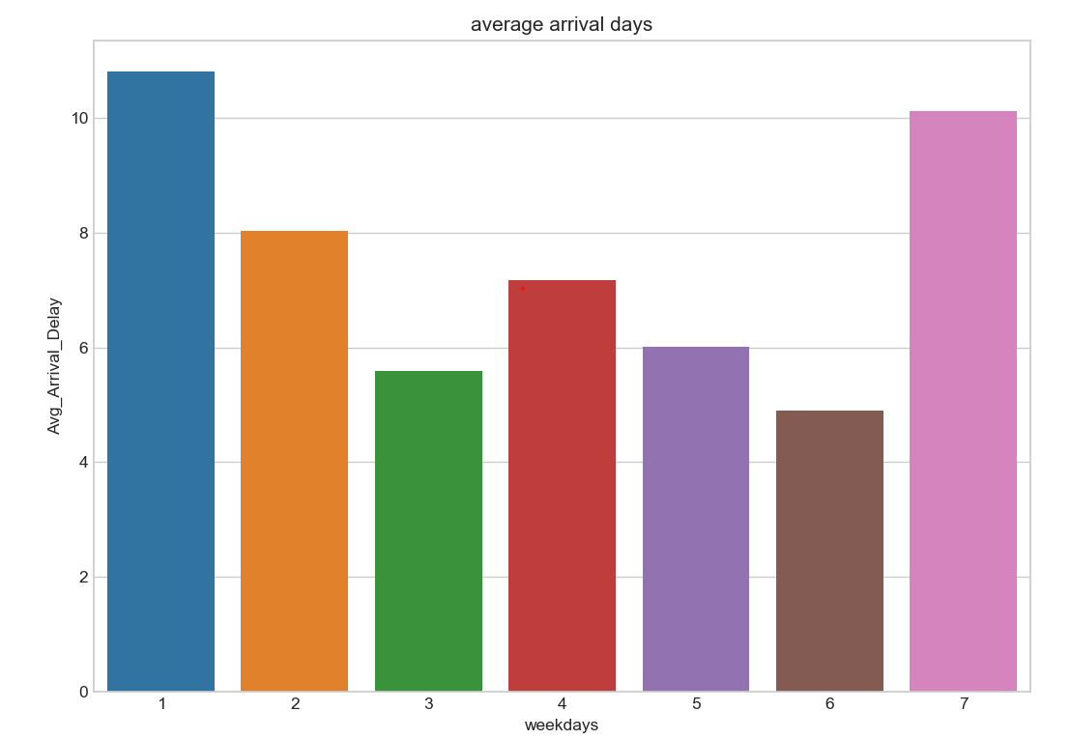

**#e)** Arrange Days of month as per cancellations done in descending order.

    #   [Create a suitable plot using matplotlib/seaborn]

day_per_cancel = collection.aggregate([{'$match' : {'CANCELLED':1}},

                                    {'$group':{'_id':'$DAY',

                                    'Cancellation_Count':{'$count':{}}}},

                                     {'$sort':{'Cancellation_Count': -1}}])

day_per_cancel_df=pd.DataFrame(day_per_cancel)

plt.style.use('seaborn-whitegrid')

plt.figure(figsize = (10,7))

sns.barplot(x=day_per_cancel_df['_id'],y=day_per_cancel_df['Cancellation_Count'])

plt.title('Days of Month  Cancellations in Descending Order')

plt.xlabel('Days')

plt.show()

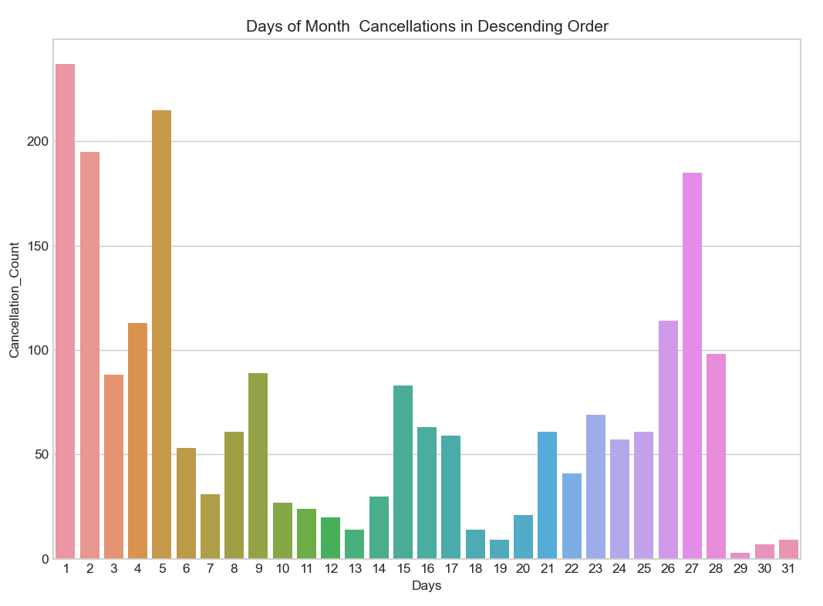

**#f)** Find the busiest airports with respect to day of week. Create a suitable plot using matplotlib/seaborn.

arrival_airport_cnt =collection.aggregate([{'$group':{'_id':'$DAY_OF_WEEK'

                                              ,'count':{'$count':{}}}},

                                            {'$sort':{'DESTINATION_AIRPORT': -1}}])

dep_airport_cnt = collection.aggregate([{'$group':{'_id':'$DAY_OF_WEEK'

                                              ,'count':{'$count':{}}}},

                                             {'$sort':{'ORIGIN_AIRPORT': -1}}])

arrival_airport_cnt_df=pd.DataFrame(arrival_airport_cnt)

dep_airport_cnt_df =pd.DataFrame(dep_airport_cnt)

dict1= arrival_airport_cnt_df.to_dict()

print(arrival_airport_cnt_df)



**#g** Find top 10 Airlines of US. Create a suitable plot using matplotlib/seaborn.

top_US_airlines=collection.aggregate([{'$group':{'_id':'$AIRLINE'

                                          ,'Airline_Count':{'$count':{}}}},

                            {'$sort':{'Airline_Count': -1}}, {'$limit':10}])

top_US_airlines = collection.aggregate([{ '$match':{'AIRLINE':"US"}},

                                        {'$group' :{'_id' : '$FLIGHT_NUMBER', 'Airline_Count':{'$count' : {}}}},

                                            {'$sort':{'Airline_Count':-1}},

                                            {'$limit':10}])

airline_df=pd.DataFrame(top_US_airlines)

plt.style.use('seaborn-whitegrid')

plt.figure(figsize = (10,7))

sns.barplot(x=airline_df['_id'],y=airline_df['Airline_Count'])

plt.title('Top 10 Airlines of US')

plt.xlabel('Flight Number')

plt.show()

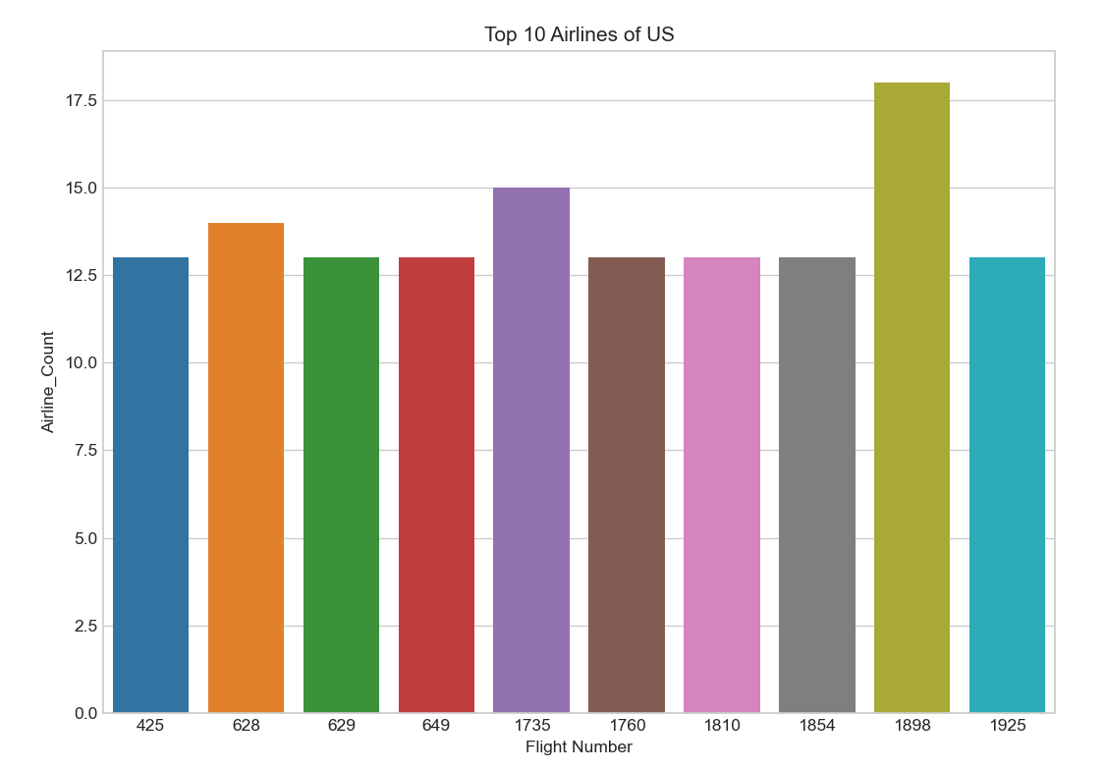

**#h)** Finding airlines that make the maximum, minimum number of cancellations.

min_cancellation = collection.aggregate([{'$match' : {'CANCELLED':1}},

                                   {'$group':{'_id':'$AIRLINE',

                                    'min_cancellation':{'$count':{}}}},

                                   {'$sort':{'min_cancellation': 1}}, {'$limit':1}

                                         ])

for i in min_cancellation:

        print(i)

max_cancellation = collection.aggregate([{'$match' : {'CANCELLED':1}},

                                   {'$group':{'_id':'$AIRLINE',

                                  'max_cancellation':{'$count':{}}}},

                                  {'$sort':{'max_cancellation': -1}}, {'$limit':1}

                                        ])

for i in max_cancellation:

        print(i)

{'_id': 'HA', 'min_cancellation': 3} {'_id': 'MQ', 'max_cancellation': 414}

**# i)** Find and show airlines names in descending that make the most number of diversions made.

    #    [Create a suitable plot using matplotlib/seaborn]

airline_diversion = collection.aggregate([{'$match' : {'DIVERTED':1}},

                                    {'$group':{'_id':'$AIRLINE',

                                 'No_of_Diversions':{'$count':{}}}},

                                {'$sort':{'No_of_Diversions': -1}}])

airline_diversion_df=pd.DataFrame(airline_diversion)

plt.style.use('seaborn-whitegrid')

plt.figure(figsize = (10,7))

sns.barplot(x=airline_diversion_df['_id'],y=airline_diversion_df['No_of_Diversions'])

plt.title('Airlines diversion in Descending Order')

plt.xlabel('Airlines')

plt.show()

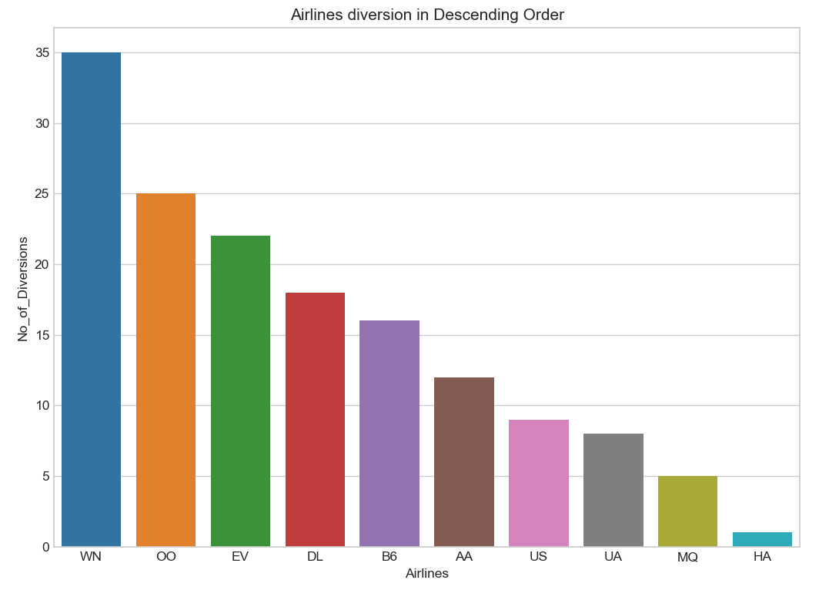

**#j)** Finding days of month that see the most number of diversion

no_of_diversions = collection.aggregate([{'$match' : {'DIVERTED':1}},

                                     {'$group':{'_id':'$DAY',

                                     'No_of_Diversions':{'$count':{}}}},

                                     {'$sort':{'No_of_Diversions': -1}},{'$limit':1}

                                           ])

for i in no_of_diversions:

         print(i)

{'_id': 2, 'No_of_Diversions': 15}

**#k**) Calculating mean and standard deviation of departure delay for all flights in minutes

departure_delay = collection.find({},{'DEPARTURE_DELAY':1,'_id':0})

departure_delay_df=pd.DataFrame(departure_delay)

print("Mean:",departure_delay_df.mean())

print("Standard Deviation:",departure_delay_df.std())

Mean: DEPARTURE_DELAY 11.329091 dtype: float64

Standard Deviation: DEPARTURE_DELAY 39.620916 dtype: float64

**#l)** Calculating mean and standard deviation of arrival delay for all flights in minutes

arrival_delay = collection.find({},{'ARRIVAL_DELAY':1,'_id':0})

arrival_delay_df=pd.DataFrame(arrival_delay)

print("Mean:",arrival_delay_df.mean())

print("Standard Deviation:",arrival_delay_df.std())

Mean: ARRIVAL_DELAY 7.545458 dtype: float64

Standard Deviation: ARRIVAL_DELAY 42.378386 dtype: float64

**#m** Create a partitioning table “flights_partition” using partitioned by schema “CANCELLED”

**#n)** Finding all diverted Route from a source to destination Airport & which route is the most diverted route.

**#o**) When is the best time of day/day of week/time of year to fly with minimum delay

total_delay=collection.aggregate([{'$group':{'_id':'$_id','total':{'$sum':'$ARRIVAL_DELAY'}}},{'$sort': {'total':1}},

                                  {'$limit':1}])

for i in total_delay:

 print(i)

{'_id': ObjectId('63649e59979ab9ec901003d4'), 'total': -76.0}